Winter 2026 CS 497 Capstone Project
Final Report
Enhancing Aerospace Supply Chain Resilience: A Predictive Analytics Approach to Mitigate Lead-Time Volatility

Parmbir Singh
Advisor: Tomas Huber
BS in Computer Science
School of Technology and Computing (STC)
City University of Seattle (CityU)
singhparmbir@cityuniversity.edu, hubertomas@cityu.edu

Abstract

Aerospace manufacturing relies on complex global supply networks that are highly sensitive to disruption. Traditional supply chain management approaches depend on reactive planning models and historical averages, which contribute to lead-time volatility and production delays. This project develops a data analytics framework to analyze supply chain behavior using aerospace production data, freight indices, and supply chain pressure indicators.

The dataset was processed and engineered using Databricks, where additional features such as volatility measures and pressure changes were created to capture instability patterns. The data was then visualized in Power BI to identify trends and relationships between variables.

The analysis revealed a strong positive relationship between production and supply chain pressure, along with persistent volatility over time. These findings indicate that aerospace supply chain instability is structural rather than temporary. The results support the use of predictive analytics to enable proactive decision-making and improve supply chain resilience.

Keywords: Supply Chain Risk Management, Predictive Analytics, Aerospace Manufacturing, Lead-Time Volatility, Machine Learning, Data Analytics, Supply Chain Resilience, Geopolitical Disruption

GitHub: https://github.com/AkQuik559/Winter-2025-CS-497-Capstone-Project-Proposal-Enhancing-Aerospace-Supply-Chain-Resilience.git

1. INTRODUCTION

The aerospace industry depends on a tightly connected global supply network, where even small delays in specialized components can disrupt production. Companies like Boeing rely on multiple tiers of suppliers, which makes their assembly lines especially sensitive to supply chain interruptions. This project examines how Data Analytics and Machine Learning can shift supply chain management from a reactive approach to a proactive, resilience-focused strategy. By using predictive models to anticipate fluctuations in lead times, the research aims to help organizations identify risks early and prevent delays before they impact production.
In recent years, increasing global complexity, supplier constraints, and geopolitical instability have intensified supply chain disruptions across the aerospace sector. These disruptions highlight the limitations of traditional supply chain models, which rely heavily on historical averages and reactive decision-making. As a result, there is a growing need for data-driven approaches that can better capture variability and support more informed operational planning.

Problem Statement

Aerospace supply chains rely on globally distributed supplier networks that must deliver highly specialized components on tightly coordinated schedules. Despite the complexity of these systems, many aerospace manufacturers continue to depend on reactive planning models and historical delivery averages. Limited multi-tier supplier visibility and insufficient risk modeling have contributed to recurring lead-time volatility, supplier bottlenecks, and production delays. As global volatility increases, traditional reactive supply chain strategies have proven inadequate for mitigating disruption risk.

Motivation

Supply chain instability in aerospace manufacturing produces measurable operational and financial consequences. Production slowdowns, capacity underutilization, and delayed aircraft deliveries expose manufacturers to revenue loss and reputational risk. Academic and industry research further demonstrates that supplier disruptions propagate across interconnected networks and are increasingly influenced by geopolitical instability. These findings highlight the need for proactive, analytics-driven risk detection mechanisms capable of identifying volatility before it impacts assembly operations.

Approach

This capstone applies a structured data analytics framework to examine relationships between aerospace production, freight activity, and global supply chain pressure. Using Databricks for data processing and Power BI for visualization, multiple datasets were cleaned, aligned, and combined into a unified time-series dataset. Additional engineered features, including volatility measures and supply chain pressure changes, were developed to better capture instability patterns. The analysis focuses on identifying trends, correlations, and fluctuations within the supply chain system to build a foundation for future predictive modeling.

Conclusions

Initial analysis indicates that supply chain pressure increases alongside production levels and does not stabilize quickly over time. The presence of continuous volatility suggests that aerospace supply chain instability is persistent rather than temporary. These findings reinforce the need for predictive, data-driven approaches that enable organizations to move from reactive disruption response toward proactive risk management and improved operational resilience.
2. BACKGROUND

The aerospace supply chain represents one of the most complex and highly integrated manufacturing ecosystems in the world. Aircraft production depends on thousands of precision-engineered components sourced from a globally distributed network of suppliers operating across multiple tiers. These components include engines, avionics systems, structural assemblies, and interior components, all of which must arrive on tightly synchronized schedules to maintain production timelines. Due to this level of interdependence, even minor delays in a single component can cascade across the entire production system.

Lead-time volatility refers to unpredictable variation in the time required for suppliers to deliver components. In aerospace manufacturing, this volatility may result from supplier capacity constraints, workforce shortages, transportation bottlenecks, regulatory delays, or geopolitical disruptions. Because aerospace supply chains are highly interconnected, disruptions can propagate across multiple tiers, amplifying instability and making it difficult to isolate root causes.

Traditional supply chain management approaches in aerospace have relied heavily on historical averages and reactive coordination strategies. While these approaches were effective in relatively stable environments, they are increasingly inadequate in today’s dynamic global landscape. Limited visibility into second- and third-tier suppliers further complicates the ability to detect and respond to emerging risks in a timely manner.

Recent advancements in data analytics and machine learning provide new opportunities to address these challenges. Predictive analytics enables organizations to analyze large volumes of operational data to identify patterns that signal potential disruption. By leveraging these techniques, aerospace manufacturers can transition from reactive problem-solving to proactive risk management, improving overall supply chain resilience.
3. RELATED WORK

Existing literature consistently identifies aerospace supply chains as highly vulnerable due to their reliance on reactive decision-making and limited supplier visibility. Government reports, industry analyses, and academic research have all highlighted structural weaknesses in traditional supply chain models.

The U.S. Government Accountability Office (GAO) identified key challenges such as limited multi-tier supplier visibility, component shortages, and delayed deliveries that directly impact production schedules. These findings indicate that many aerospace manufacturers rely on reactive problem-solving rather than proactive risk identification.

Peer-reviewed research further supports these observations. Studies have shown that lead-time variability significantly disrupts inventory management and production scheduling. Multi-tier supplier networks introduce additional complexity, as disruptions at lower tiers can propagate throughout the entire supply chain, increasing overall system instability.

Industry reports provide real-world validation of these challenges. Major manufacturers such as Boeing and Airbus have experienced production slowdowns due to supplier capacity constraints and logistics disruptions. These issues have led to delayed aircraft deliveries and adjustments in production targets, highlighting the operational impact of supply chain instability.

At the same time, emerging research and industry practices point toward predictive analytics as a potential solution. Digital supply chain technologies, machine learning models, and real-time data integration systems are being developed to improve visibility and enable proactive decision-making. These approaches allow organizations to identify risk patterns earlier and adjust operations accordingly.

Collectively, the literature demonstrates a clear gap between traditional reactive supply chain models and modern data-driven approaches. This gap reinforces the need for predictive analytics frameworks capable of improving risk detection and enhancing aerospace supply chain resilience.
4. APPROACH

This project follows a structured data analytics approach designed to identify patterns of instability within aerospace supply chains. Rather than immediately implementing full machine learning models, the focus at this stage is on building a strong analytical foundation through data preparation, feature engineering, and visualization.

The system is designed to analyze relationships between aerospace production, freight activity, and global supply chain pressure. These variables represent key indicators of supply chain performance and provide insight into how production demand interacts with logistical constraints.

User Requirements
The system must identify patterns of instability, detect volatility, and provide interpretable insights that support decision-making. The outputs must be clear and actionable to ensure usability for operational stakeholders.

Design
The system follows a modular pipeline consisting of:
- Data ingestion and integration
- Data cleaning and preprocessing
- Feature engineering (volatility measures and pressure changes)
- Visualization of trends, volatility, and correlations

Implementation
Data was processed using Databricks, where multiple datasets were cleaned, aligned, and merged into a unified time-series dataset. Feature engineering techniques were applied to generate additional indicators that capture instability patterns. The dataset was then exported to Power BI for visualization and analysis.

Data Cleaning & Preprocessing

The datasets were preprocessed in Databricks to ensure consistency and reliability for analysis. Missing values were handled using forward-fill techniques for time-series continuity, and inconsistent date formats were standardized to a unified monthly format.

Outliers were identified using a threshold-based filtering approach. Data points exceeding ±2 standard deviations from the mean were reviewed and removed if they represented anomalies rather than meaningful variation. This threshold was selected to preserve natural variability while eliminating extreme distortions that could bias trend and correlation analysis.

All datasets were normalized to ensure comparability across variables with different scales. This step was necessary to accurately analyze relationships between aerospace production, freight activity, and supply chain pressure.

Why These Technologies

Databricks was selected due to its scalability and ability to process large datasets efficiently using distributed computing. It also supports Python-based data manipulation, which enables flexible feature engineering and preprocessing.

Power BI was chosen for visualization because it allows interactive dashboard creation and clear representation of trends, volatility, and correlations. This supports the user requirement of generating interpretable insights for decision-making.

GitHub was used to ensure version control and reproducibility, allowing all steps of the data pipeline to be documented and revisited if necessary.

Technologies Used

- Databricks (Python) for data processing and feature engineering
- Power BI for visualization and dashboard development
- GitHub for version control and project documentation
5. DATA COLLECTION
The dataset used in this project was constructed from structured variables representing aerospace production, freight index activity, and supply chain pressure. These variables capture different dimensions of supply chain performance, including manufacturing output, logistics activity, and global disruption levels.
Data was collected from structured secondary sources and processed within the Databricks environment. Preprocessing steps included data cleaning, formatting, normalization, and alignment across time-series intervals. The datasets were then merged into a single unified dataset to support integrated analysis.
The resulting dataset contains curated data points that reflect the interaction between production demand and supply chain constraints over time. This dataset serves as the foundation for all subsequent analysis and visualization.
6. DATA ANALYSIS

Data analysis was conducted using Power BI to explore patterns, trends, and relationships within the dataset. Multiple analytical techniques were applied to gain a comprehensive understanding of supply chain behavior.

Time-series analysis was conducted to examine trends in aerospace production and supply chain pressure over time. The results indicate a consistent upward trend in both variables, suggesting that increases in production are associated with rising supply chain pressure. As shown in Figure 1, both aerospace production and supply chain pressure increase steadily across the observed time period.

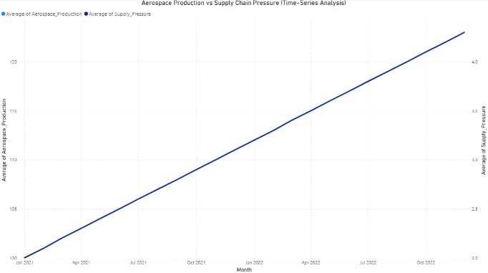
Figure 1. Aerospace Production vs Supply Chain Pressure (Time-Series Analysis).

To further examine instability within the supply chain, monthly changes in supply chain pressure were analyzed. The results show frequent fluctuations in pressure levels over time, indicating ongoing volatility within the system. As shown in Figure 2, supply chain pressure does not remain stable and instead exhibits repeated increases and decreases across multiple periods.

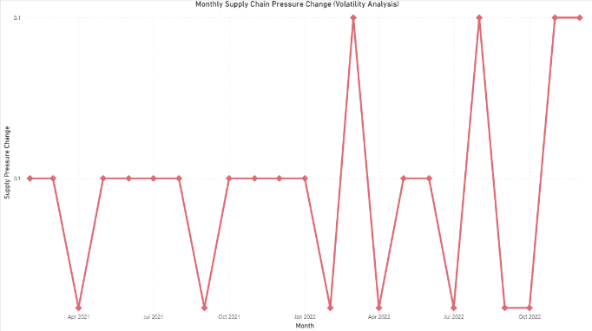
Figure 2. Monthly Supply Chain Pressure Change (Volatility Analysis).

Correlation analysis was performed to evaluate the relationship between aerospace production and supply chain pressure. The results indicate a strong positive relationship between the two variables, suggesting that higher production levels are associated with increased supply chain pressure. As shown in Figure 3, supply chain pressure increases proportionally with aerospace production.

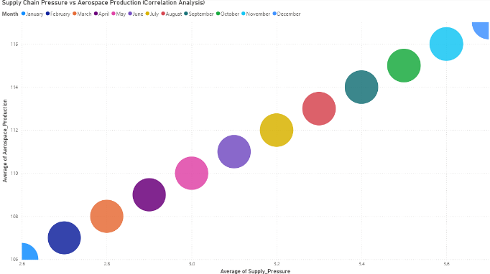
Figure 3. Supply Chain Pressure vs Aerospace Production (Correlation Analysis).

These analytical techniques collectively provide evidence of trends, variability, and relationships within the supply chain system.

The combination of time-series, volatility, and correlation analysis ensures a comprehensive evaluation of supply chain behavior. These methods were selected because they allow both trend identification and variability detection, which are critical for understanding instability in complex supply systems.

These visualizations support the findings by clearly illustrating trends, volatility, and relationships within the dataset.
7. FINDING

Several key findings were identified from the analysis. Aerospace production showed a consistent upward trend over the observed time period. Supply chain pressure also increased alongside production levels, indicating a parallel movement between these variables.

Monthly supply chain pressure changes exhibited continuous fluctuation throughout the dataset, reflecting variability in supply chain conditions over time. Additionally, correlation analysis revealed a strong positive relationship between aerospace production and supply chain pressure, with higher production levels corresponding to higher measured pressure values.

These results summarize the observed relationships and patterns identified within the dataset.
8. CONCLUSION

The results of this analysis demonstrate that aerospace supply chain instability is persistent and closely tied to production growth. As production increases, supply chain pressure also increases, indicating that the system operates under continuous strain rather than experiencing temporary disruptions.

The presence of sustained volatility further supports the conclusion that instability is structural in nature. These findings highlight the limitations of reactive supply chain management approaches and reinforce the need for predictive, data-driven strategies to improve resilience and decision-making.
9. FUTURE WORK

Future work will focus on expanding the analytical framework to include real-world aerospace supply chain data and implementing machine learning models to improve forecasting accuracy.

Additional enhancements include developing supplier-level risk scoring mechanisms and expanding the Power BI dashboard to support real-time monitoring and decision-making. These improvements will increase the practical applicability of the system and provide greater value for industry use.

Further research may also explore advanced modeling techniques, such as time-series forecasting and ensemble machine learning models, to improve prediction performance and better capture complex supply chain dynamics.
10. REFERENCE

Bednarski, L., Roscoe, S., Blome, C., & Schleper, M. C. (2023). Geopolitical disruptions in global supply chains: A state-of-the-art literature review. Production Planning & Control, 1–27. https://research.lancaster-university.uk/en/publications/geopolitical-disruptions-in-global-supply-chains-a-state-of-the-a/

Douaioui, K. (2024, September). Machine learning and deep learning models for demand forecasting in supply chain management: A critical review. ResearchGate. https://www.researchgate.net/publication/384388190_Machine_Learning_and_Deep_Learning_Models_for_Demand_Forecasting_in_Supply_Chain_Management_A_Critical_Review

Deloitte. (2023). 2023 aerospace and defense industry outlook. https://www.deloitte.com/global/en/Industries/defense-security-justice/analysis/gx-aerospace-and-defense-industry-outlook.html

Deloitte. (2025). 2025 aerospace and defense industry outlook. https://www.deloitte.com/us/en/insights/industry/aerospace-defense/aerospace-and-defense-industry-outlook/2025.html

Deloitte. (2026). 2026 aerospace and defense industry outlook. https://www.deloitte.com/us/en/insights/industry/aerospace-defense/aerospace-and-defense-industry-outlook.html

Ganapavaram, A. (2024, March 12). U.S. airlines warn of more Boeing delivery delays due to safety crisis. Reuters. https://www.reuters.com/business/aerospace-defense/southwest-cuts-delivery-forecast-boeing-2024-03-12/

Hamilton, S. (2025, December 8). Supply chain continues to bedevil Airbus, Boeing. Leeham News and Analysis. https://leehamnews.com/2025/12/08/supply-chain-continues-to-bedevil-airbus-boeing/

Lagut, S., Ram, R., Compton, N., & Cadenazzi, M. (2025, July 10). How can digital supply chains help manage aerospace risk? EY Insights. https://www.ey.com/en_us/insights/aerospace-defense/how-can-digital-supply-chains-help-manage-aerospace-risk

Lampert, A. (2024, September 10). Boeing delays suppliers’ 737 MAX output goal by 6 months, sources say. Reuters. https://www.reuters.com/business/aerospace-defense/boeing-delays-suppliers-737-max-output-goal-by-6-months-sources-say-2024-09-09/

